Name:
Katelyn Clark-Martin
Create a QR Code Hunt
Type the information next to each prompt.

- Choose a topic: Phases of Matter
- Identify the standards and write objectives:

OBJECTIVES: This QR hunt is meant to help students become more familiar with the phases of matter. Each piece of this hunt introduces them to more information about the phases. Also, the other objective of this QR hunt is meant to get students even more familiar with QR codes and how they work. STANDARDS: This hunt correlates directly with the Colorado state standards in science. Specifically it relates to standard I. Physical Science: Students know and understand common properties, forms, and changes in matter and energy. 1. Matter exists in different states such as solids, liquids, and gases and can change from one state to another by heating and cooling. As far as the ISTE standards it connects with standards 3 and 6.

- Determine how you want students to proceed through the QR code hunt and what they are to do with the information or what they are to do at each clue. Describe your method here:

Split the class into partners using your chosen partner selection process (my favorite partner picking option is the app, Randomly). These partners will travel around the room together and learn about the stages of matter as a pair.

It’s helpful to post QR Codes with pictures and numbers in order for the partners to stay better organized on their journey.

There will be a question or prompt next to each QR station. The students will carry their science notebooks around and answer the prompt or question.

- Write at least 10 questions or prompts (see table below):
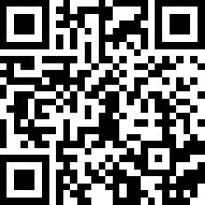1--What is matter? Tell me in your own words and draw a picture that you think represents matter.

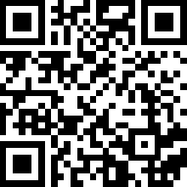2—What are the three states of matter?

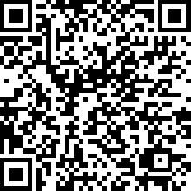3—After seeing this picture of a solid, please provide a few of your own examples of things you think are solids. Don’t forget to include pictures.
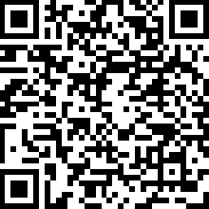4—After seeing this picture of a liquid, please provide a few of your own examples of things you think are liquids. Don’t forget to include pictures.
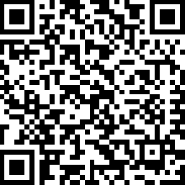5—Examine the picture of a gas (remember to look at what the arrow is pointing at). Then, please provide a few of your own examples of things you think are gases. Don’t forget to include pictures.

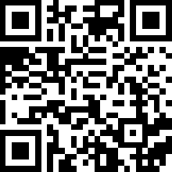6-After listening to the song, please write two characteristics for each of the states of matter.
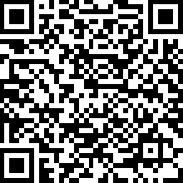7-After looking at the list of solid characteristics, please write a short poem about solids.
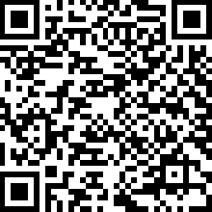8-- After looking at the list of liquid characteristics, please write a short poem about liquids.
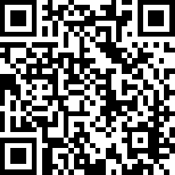9-- After looking at the list of gas characteristics, please write a short poem about gases.
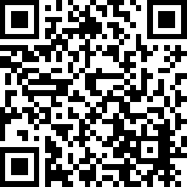10—After watching this cool video about phase changes, which one is your favorite from the video? Why?

- Create a QR code for each question/prompt. Copy and paste the QR code next to each question/prompt above. QR codes can link to text, web sites, images, and more!

There are a lot of QR code generators. Some have colors, some allow many options, some are just black and white, and some force you to download the QR code.
This QR code generator allows you to copy and paste rather than download: http://goqr.me/
This one has lots of options and color: http://www.qrstuff.com/

- Here is a QR code hunt generator: http://www.classtools.net/QR/

Example:
Question | QR Code
What is mobile learning? | 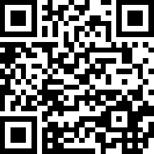

You can use a table to organize your hunt.

