Comic Book Character Description with the Use of Bit Strips
Author | Katelyn Clark-Martin
Grade Level | 2nd grade
Integrated disciplines | (Example: math, science, technology, writing)  This lesson integrates technology and writing.
Content Standards | Provide applicable standards for which you intend the students to meet through this lesson in each of your integrated disciplines.  This is a technology and writing lesson. Because the students will be writing simple descriptive pieces, the standards are within the writing and composition standards along with technology standards of the NETS-S.
Writing Standards | Standard 3) Writing and Composition  1. Exploring the writing process helps to plan and draft a variety of literary genres  2. Exploring the writing process helps to plan and draft a variety of simple informational texts  3. Appropriate spelling, capitalization, grammar, and punctuation are used and applied when writing  Students can:  a. Write opinion pieces in which they introduce the topic or  book they are writing about, state an opinion, supply  reasons that support the opinion, use linking words (e.g.,  because, and, also) to connect opinion and reasons, and  provide a concluding statement or section. (CCSS: W.2.1)  b. Write narratives in which they recount a well-elaborated  event or short sequence of events, include details to  describe actions, thoughts, and feelings, use temporal  words to signal event order, and provide a sense of  closure. (CCSS: W.2.3)  c. Organize ideas using pictures, graphic organizers, or story  maps  d. Write simple, descriptive poems  e. Write with precise nouns, active verbs, and descriptive  adjectives  f. Use a knowledge of structure and crafts of various forms of  writing gained through reading and listening to mentor  texts  g. Develop characters both internally (thoughts and feelings)  and externally (physical features, expressions, clothing)
NETS-S | Standard 1 (Creativity and Innovation), and Standard 6 (Technology Operations and Concepts)
Objectives: | Students will be able to (master content, skills, etc.) by (doing what?).  Students will be able to learn how to use Bit Strips by creating a comic about themselves as comic book characters. Students will use descriptive language in order to explain what they would be in a comic book and provide a basic description of themselves as comic book characters.
Assessment: | Teacher will assess students’ (progress, knowledge gained, mastery of) by (rubric, quiz, observation)  Observation will be the assessment in this lesson. Watching the students create their bit strips will be the main assessment piece. I will also be looking at the finished product to see how the description flows.
Materials: | Computers or tablets that contain the Bit Strips application  Drafting for descriptions can also be done on paper.
Anticipatory Set: | The hook of the lesson. How will you get students interested in this lesson? How will you grab their attention?  I will show the students a few comic books along with Bit Strip examples. I will start the lesson out by wearing a cape, and asking if the students have ever dreamt about what they would be as comic book characters. This will open the floor for discussion and brainstorming!
Technology Integration | Brief explanation (2-3 sentences)  Think of your TPACK.:  This lesson will allow students to explore their technological creativity using the Bit Strips application. They will be able to gain knowledge on a technology that can be used for a variety of uses. They will also be able to integrate their writing skills and creative writing with their technological illustration skills.
Procedures and Learning Activities | Students: | Teacher:
 | Think of the various educational theories and concepts for best practices.  Students will create a Bit Strip illustrating what they would be as a comic book character.  Describe what they would be as a comic book character using descriptive language. | The instructor must introduce the lesson with a hook like listed above.  Brainstorming prior to the students starting the application process.  The instructor should observe the students create their comic book characters using Bit Strips as a form of assessment.  They should also assist in helping students write short descriptions of themselves as comic book characters.
Differentiation | How will you adjust the lesson for higher ability learners and learners with disabilities? Provide a few suggestions.  Provide a mini-lesson that shows the students how to use Bit Strips in order to help students start the lesson on an even playing fluid.  For those with literacy challenges—adjust what is expected as far as length in the descriptions.  For students that finish early, they can expand on their bit strip and descriptive writing length.
Closure | How will you bring the lesson full circle to allow students to reflect on their learning and acknowledge meeting of the objectives?  We will have a share about or gallery walk in the classroom so the students can see each others ideas illustrated and described!  We will talk about descriptions as well.
References: | Cite any resources used to create the lesson plan and which will be used to present the lesson.  Colorado State Standards  ISET standards  Bit Strips
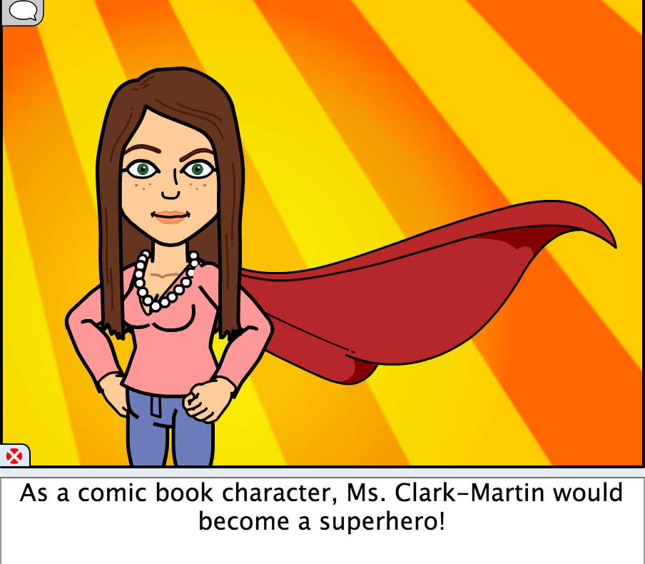
Example of finished product is provided above. This is meant to be a simple bit strip comic to allow for a simple writing description and for the students can expand on their bit strip length if needed. The length can be expanded on for higher grade levels.

